How to display device time in a meter template
Question: In PecView at the meter template, device time on all meters always display “N/A”
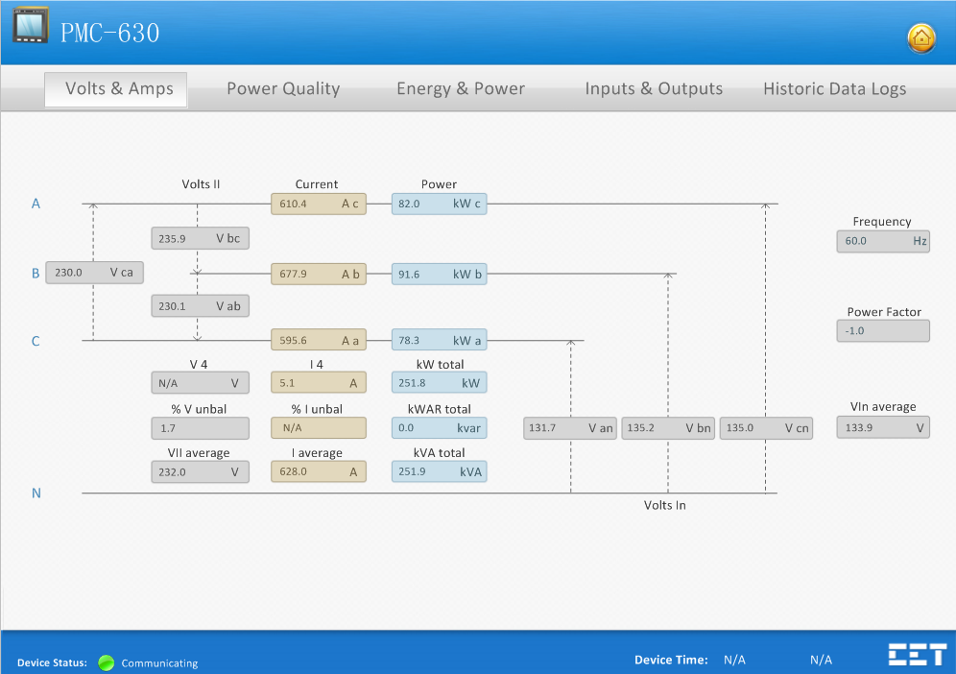
Answer:
There are two possibilities if the Device Time is showing N/A:
- the device time is not imported from the SNF file in PecConfig.
- the device time is not mapped to real-time mapping.

Please following the below steps:
- Check if Device Time exists in PecConfig in the way:
- Select the device and right-click on it, select Export SNF File from the pop-up window. Enter a name for the snf file and save it.
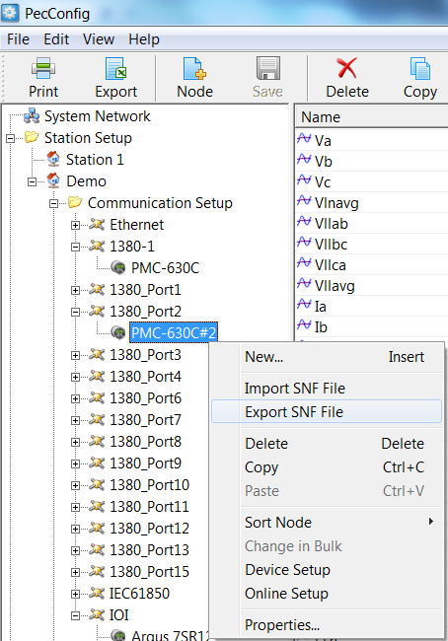
- Open the snf file and search by the keyword: Device Time. If it is not found, go to step 2). If it is found, then go to step 3).
The PMC-630 driver’s definition:
A10000 = Device Time

- There are more than 1024 data points in the default snf file of PMC-630 series, PMC-660, etc. When importing the SNF file, PecConfig will cut out additional data points if exceed 1024, which result in the Device Time is not imported. In order to reduce the impact to the existing system, I suggest to modify the data points of the device in PecConfig:
- Delete one or more data points that do not need (for example, AI measurement, Year, Month, Day, Hour, Minute, Second of the max/min parameters)
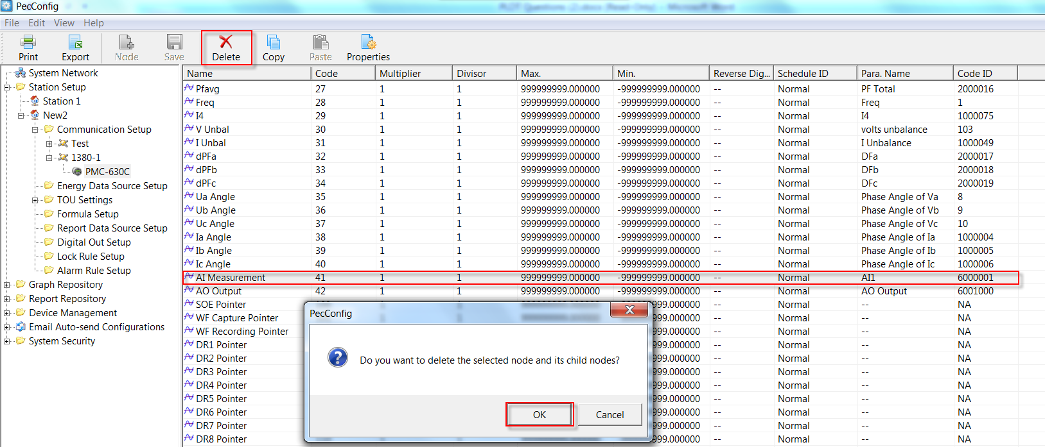
- Add Device Time source to the device. Select the device and click the Node icon from the tool bar, the Select Source Type window appears. Select Analog and click OK to add an analog source.
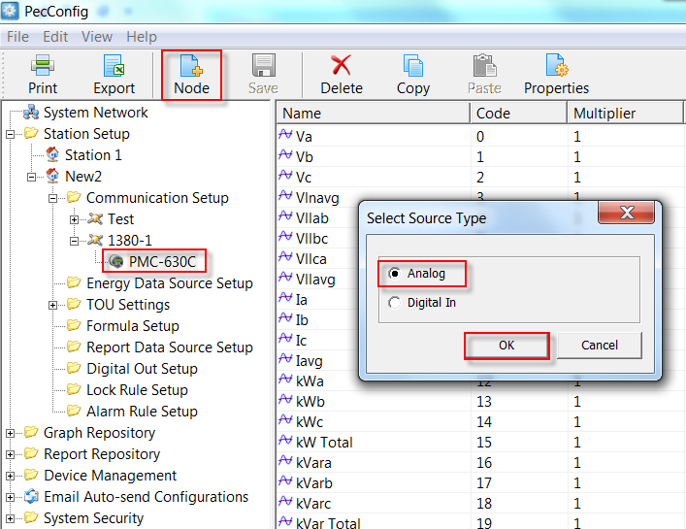
- Enter 10000 in the Code field, the Name changes to Device Time automatically, and then click OK.
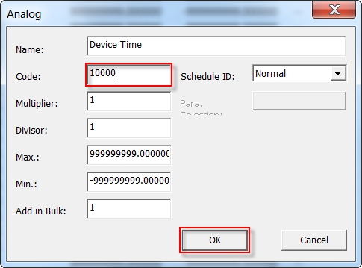
- The Device Time is added. Then click Save to save changes to database.
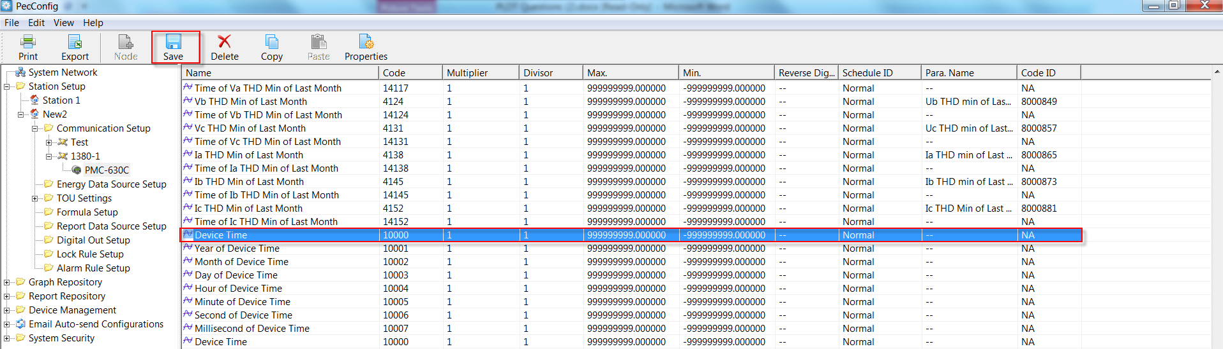

- Double-click Device Time and the Analog Properties window appears.
- Change Schedule ID from Normal to Custom. And click Para. Selection button.
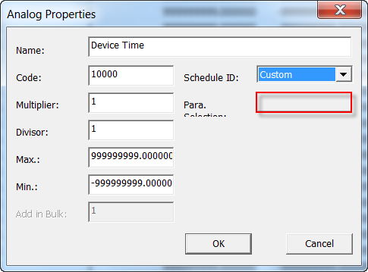
- The Para. Selection window appears. Select Non-electricity Points Common Points Device Time and click OK and return to the main window.
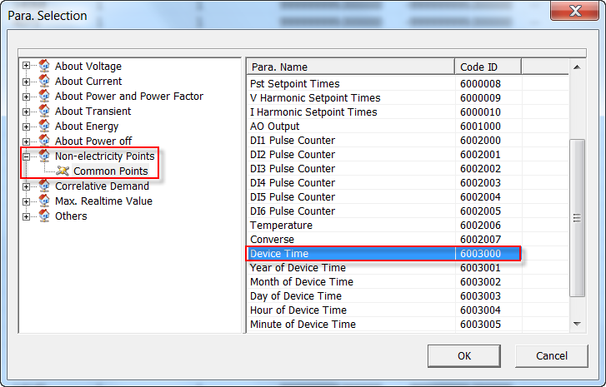
- Then the Device Time is mapped to real-time mapping as below. Save changes to database.
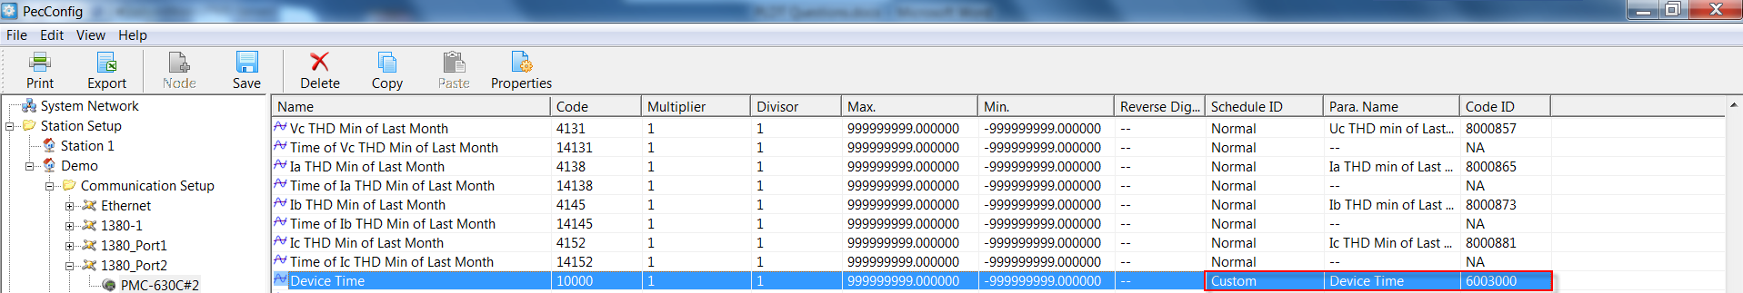
- Restart PecView.

